NETWORKING-3
Network Protocols
Protocol is a standardized set of rules, formats, and procedures that determines how data is transmitted, received, and processed between different devices over a network.
- ARP (Address Resolution Protocol): Maps a known logical IP address to a physical, hardcoded MAC address on a local area network.
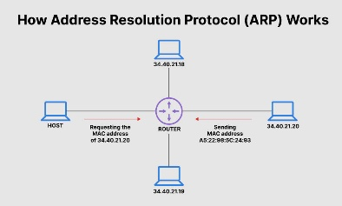
- BGP (Border Gateway Protocol): Routes data traffic across the global internet between giant networks owned by internet service providers (ISPs).
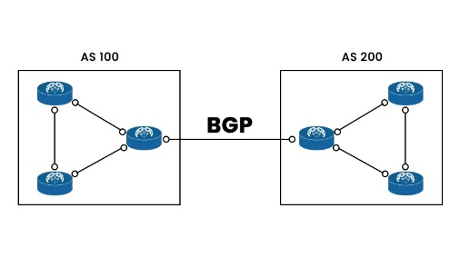
- DHCP (Dynamic Host Configuration Protocol): Automatically assigns dynamic IP addresses and configuration settings to devices when they join a network.
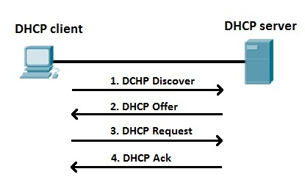
- DNS (Domain Name System): Translates human-readable domain names (like google.com) into numerical IP addresses that computers understand.
- FTP (File Transfer Protocol): Transmits raw computer files between a client and a remote server.
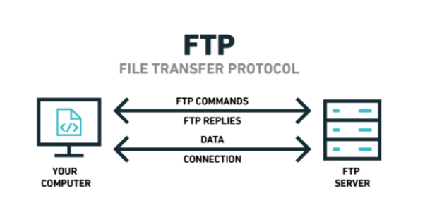
- HTTP (Hypertext Transfer Protocol): Fetches and loads standard, plaintext web pages from a server to a web browser.
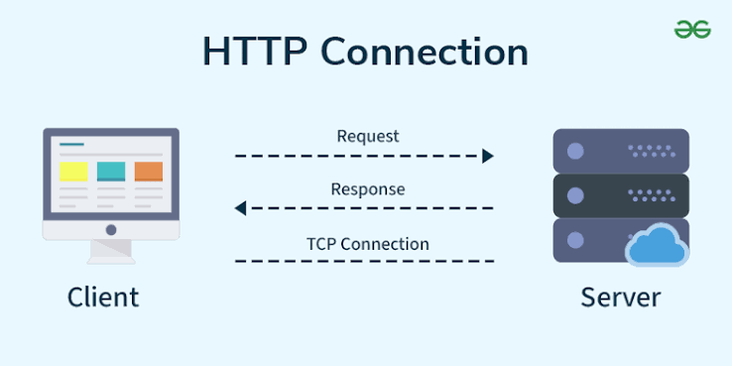
- HTTPS (Hypertext Transfer Protocol Secure): Encrypts web traffic using SSL/TLS to secure online browsing, shopping, and banking.
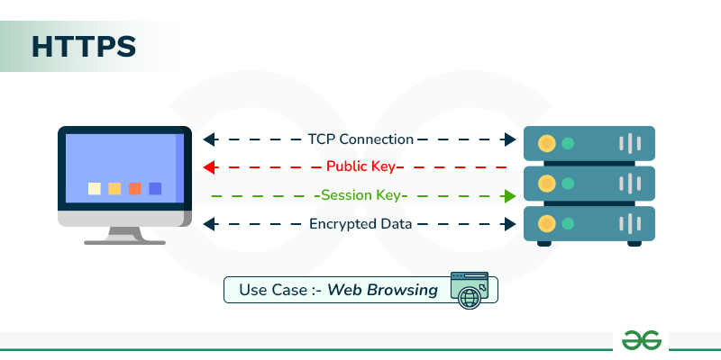
- ICMP (Internet Control Message Protocol): Sends diagnostic information and error messages; this is the core engine behind the ping command.
- IMAP (Internet Message Access Protocol): Synchronizes and manages emails interactively across multiple devices while keeping them on the server.
- IP (Internet Protocol - IPv4/IPv6): Labels data packets with unique source and destination addresses so they can be accurately routed across networks.
- IPsec (Internet Protocol Security): Encrypts and authenticates data at the network layer, commonly used to establish secure VPN tunnels.
- LDAP (Lightweight Directory Access Protocol): Centralizes user authentication and directory lookups across corporate networks.
- NTP (Network Time Protocol): Synchronizes the internal clocks of all computer systems across a network for accurate timekeeping.
- OSPF (Open Shortest Path First): Dynamically calculates the fastest, shortest data pathways within a corporate or enterprise network.
- POP3 (Post Office Protocol version 3): Downloads emails from a central server to a single local device, typically deleting them from the server afterward.
- RDP (Remote Desktop Protocol): Allows users to visually connect to and control a remote Windows computer's graphical desktop interface.
- SNMP (Simple Network Management Protocol): Gathers health and performance metrics (like CPU load and bandwidth) from routers, switches, and other network devices.
- SMTP (Simple Mail Transfer Protocol): Handles the transmission and routing of outgoing emails from clients to servers.
- SSH (Secure Shell Protocol): Provides secure, encrypted command-line access to execute administrative commands on remote servers.
- TCP (Transmission Control Protocol): Establishes a reliable, connection-oriented channel that guarantees data packets arrive sequentially and without errors.
- Telnet (Telecommunication Network): A legacy, unencrypted command-line tool for remote device access (largely replaced by SSH due to security flaws).
- TFTP (Trivial File Transfer Protocol): A simplified, lightweight version of FTP used mostly for booting up diskless workstations.
- TLS (Transport Layer Security): The modern cryptographic protocol that secures and encrypts application data (the operational engine behind HTTPS).
- UDP (User Datagram Protocol): Establishes a fast, connectionless channel that skips error checks to reduce latency, making it ideal for streaming and online gaming.
- WebSocket: Establishes a persistent, real-time, two-way communication channel between a web browser and a server.
Emerging protocols
- QUIC (Quick UDP Internet Connections): A modern transport protocol designed by Google that replaces TCP. It runs on top of UDP to establish web connections much faster, serving as the foundation for HTTP/3.
- gRPC (Google Remote Procedure Call): A high-performance protocol used extensively in modern cloud applications and microservices to communicate rapidly between servers using HTTP/2.
- MQTT (Message Queuing Telemetry Transport): A lightweight messaging protocol designed for IoT (Internet of Things) devices. It uses minimal battery and bandwidth, making it perfect for smart home tech and sensors.
- CoAP (Constrained Application Protocol): A specialized web transfer protocol for resource-constrained gadgets, allowing tiny electronics to interact over the internet like a standard website.
Network Ports
In computer networking, logical ports are software-defined endpoints that specify how data packets are delivered to precise applications or services on a machine. Identified by a 16-bit unsigned integer, there are exactly 65,536 total logical ports available (ranging from 0 to 65,535) for both the TCP and UDP transport protocols.
The Internet Assigned Numbers Authority (IANA) categorises these logical ports into three official ranges.
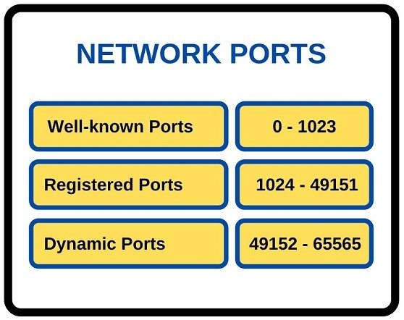
Well-known Ports
Well-Known Ports are a standardized range of network port numbers from 0 to 1023 that are strictly reserved for core internet infrastructure, operating system processes, and universally accepted network protocols.
- Port 20 (TCP) — FTP-Data (File Transfer Protocol): Transmits the actual file contents during an FTP session.
- Port 21 (TCP) — FTP-Control (File Transfer Protocol): Passes commands, handles connections, and processes user authentication.
- Port 22 (TCP) — SSH / SCP (Secure Shell): Enables secure remote terminal access and encrypted file transfers.
- Port 23 (TCP) — Telnet (Teletype Network): Provides unencrypted remote terminal management (insecure and largely obsolete).
- Port 25 (TCP) — SMTP (Simple Mail Transfer Protocol): Routes and relays outbound emails between mail servers.
- Port 53 (UDP/TCP) — DNS (Domain Name System): Translates human-readable domain names into machine-readable IP addresses.
- Port 67 (UDP) — DHCP-Server (Dynamic Host Configuration Protocol): Listens for client requests to automatically assign network configurations.
- Port 68 (UDP) — DHCP-Client (Dynamic Host Configuration Protocol): Receives the assigned IP addresses and network parameters from the server.
- Port 69 (UDP) — TFTP (Trivial File Transfer Protocol): A simplified, low-overhead file transfer protocol used frequently for network-booting devices.
- Port 80 (TCP) — HTTP (Hypertext Transfer Protocol): Serves standard, unencrypted web pages across the internet.
- Port 110 (TCP) — POP3 (Post Office Protocol v3): Downloads emails from a mail server directly to a local client and deletes them from the server.
- Port 123 (UDP) — NTP (Network Time Protocol): Synchronizes device internal clocks with high-precision global atomic clocks.
- Port 143 (TCP) — IMAP (Internet Message Access Protocol): Caches, views, and manages emails on a server while keeping them synced across multiple devices.
- Port 161 (UDP) — SNMP (Simple Network Management Protocol): Queries and monitors network hardware health, traffic, and configurations.
- Port 162 (UDP) — SNMPTRAP (SNMP Trap): Receives asynchronous error logs and alerts sent directly from network devices to a monitoring server.
- Port 179 (TCP) — BGP (Border Gateway Protocol): Core system used to exchange internet routing paths between major internet service provider networks.
- Port 389 (TCP/UDP) — LDAP (Lightweight Directory Access Protocol): Queries centralized identity databases for network user authentication.
- Port 443 (TCP) — HTTPS (Hypertext Transfer Protocol Secure): Serves encrypted web traffic utilizing modern TLS/SSL security.
- Port 445 (TCP) — SMB (Server Message Block): Used for sharing local files, directories, and printers across a Windows network.
- Port 514 (UDP) — Syslog (System Logging): Forwards operating system activity logs and security alerts to a central collection server.

Registered Ports
Registered Ports are a range of network port numbers from 1024 to 49151 assigned by IANA to specific proprietary applications, third-party software, or vendor-specific services. Unlike well-known ports, an application does not need administrative or superuser privileges to bind to a registered port on most operating systems. These numbers are officially allocated to prevent software vendors from building tools that conflict with one another.
- Port 1080 (TCP) — SOCKS Proxy: Used by proxy servers to relay networking data via a secure boundary.
- Port 1194 (UDP/TCP) — OpenVPN: The default tunnel listening port for OpenVPN networks.
- Port 1433 (TCP) — Microsoft SQL Server: Handles incoming relational database queries for MSSQL.
- Port 1521 (TCP) — Oracle Database: Standard data connection listener endpoint for enterprise Oracle environments.
- Port 1701 (UDP) — L2TP (Layer 2 Tunneling Protocol): Used to route encrypted VPN tunnel traffic.
- Port 1723 (TCP/UDP) — PPTP: Legacy point-to-point protocol endpoint used by older corporate VPN setups.
- Port 1812 & 1813 (UDP) — RADIUS: Used for centralized identity validation (1812 handles authentication, 1813 handles accounting data).
- Port 2049 (TCP/UDP) — NFS (Network File System): Used on Linux and Unix environments to mount remote folders across a local network.
- Port 3128 (TCP) — Squid Proxy: Standard communications gateway for caching and proxying web traffic.
- Port 3306 (TCP) — MySQL Server: Default endpoint used by apps to query open-source MySQL and MariaDB relational databases.
- Port 3389 (TCP) — RDP (Remote Desktop Protocol): Powers Microsoft's native visual workspace streaming solution.
- Port 5060 & 5061 (TCP/UDP) — SIP (Session Initiation Protocol): Manages connection handshakes for VoIP internet phone calls (5061 handles encrypted secure voice).
- Port 5432 (TCP) — PostgreSQL: Default communication pathway used to access PostgreSQL relational databases.
- Port 5672 (TCP) — AMQP (Advanced Message Queuing Protocol): Utilized by message brokers like RabbitMQ to orchestrate microservice data.
- Port 5900 (TCP) — VNC (Virtual Network Computing): Standard channel utilized by cross-platform remote desktop tools to view visual screen sharing profiles.
- Port 6379 (TCP) — Redis: Default port used to read and write high-speed, volatile in-memory caching databases.
- Port 6443 (TCP) — Kubernetes API Server: Crucial secure communications hub for cluster orchestration endpoints inside Kubernetes clouds.
- Port 8080 (TCP) — HTTP Alternative (Tomcat / Jenkins): Commonly deployed as a testing environment placeholder or secondary web development server port.
- Port 8443 (TCP) — HTTPS Alternative: Secondary channel often used by administration utilities to pass secure web traffic over a customized port profile.
- Port 9092 (TCP) — Apache Kafka: Handles data streaming streams and queue brokers inside Kafka event architectures.
- Port 9200 (TCP) — Elasticsearch: Listens for API data indexing search queries on Elasticsearch cluster deployments.
- Port 25565 (TCP/UDP) — Minecraft Server: The standard listening endpoint used to host local or cloud multiplayer game worlds.
- Port 27017 (TCP) — MongoDB: Standard data channel used to perform query operations on MongoDB NoSQL database documents.

Dynamic Ports
Dynamic Ports (also known as Ephemeral Ports or Private Ports) are the final range of network port numbers from 49152 to 65535 that cannot be officially registered or assigned to any specific application. Instead, they are used temporarily by an operating system as a "return address" when a client device initiates a connection to a server. For example, when your browser connects to a web server's permanent port (like Port 443), your machine randomly allocates an open dynamic port to receive the incoming response data; once you close that webpage, the port is recycled back into the available pool.

Network devices
Network devices are physical or virtual hardware components that enable connection, communication, and data control across a computer network.
- A Hub connects multiple devices in a local network but lacks intelligence, broadcasting all incoming data to every connected port, which causes high traffic and data collisions.
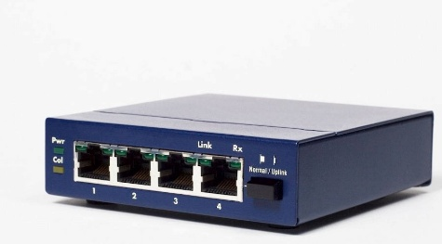
- A Switch replaces the hub by intelligently mapping the unique MAC addresses of connected devices, allowing it to forward data exclusively to its intended destination for better efficiency and security.
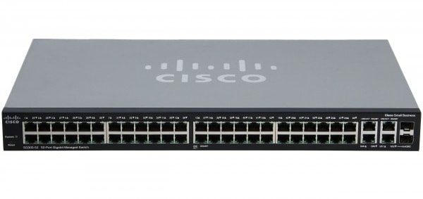
- A Router operates at a higher level by connecting entirely separate networks, such as linking a private home network to the public internet, using IP addresses to direct data packets along the most efficient paths.
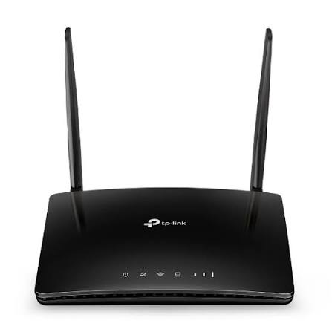
- A Wireless Access Point acts as a bridge by plugging directly into a wired switch or router and broadcasting a Wi-Fi signal, enabling wireless devices like smartphones to join the wired infrastructure.
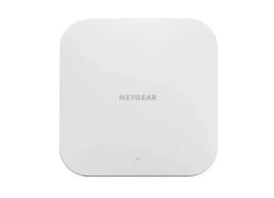
- A Repeater extends the reach of a network by taking a weak, fading signal, regenerating and amplifying it, and then retransmitting it to cover a larger physical distance.
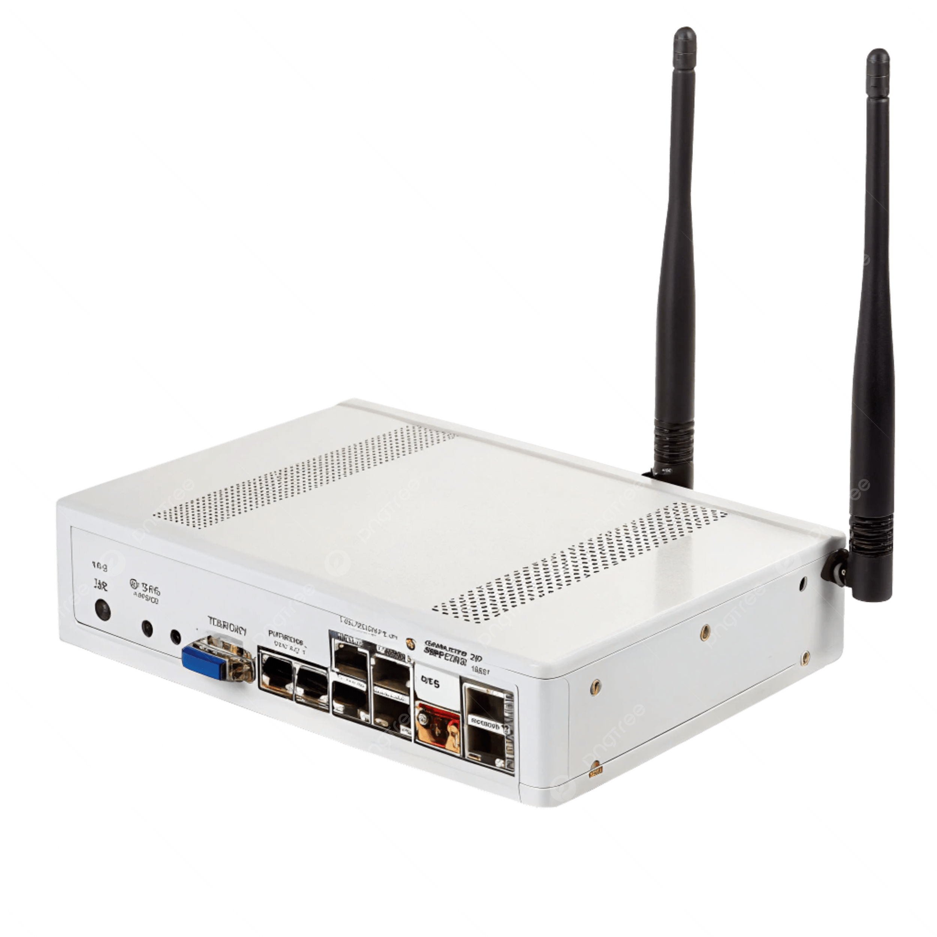

- A NIC (Network Interface) Card is the vital hardware component installed inside a computer or device that provides the physical port or wireless antenna needed to connect it to the network in the first place.
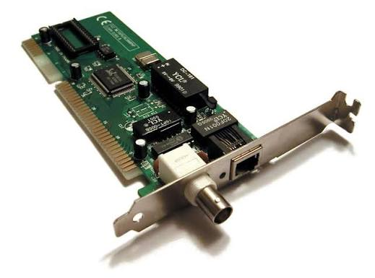
- A Gateway acts as a protocol translator between two completely different network architectures. Unlike a router which connects networks using the same protocols, a gateway converts data packets from one format to another (such as connecting an enterprise local network to a legacy mainframe computer network).
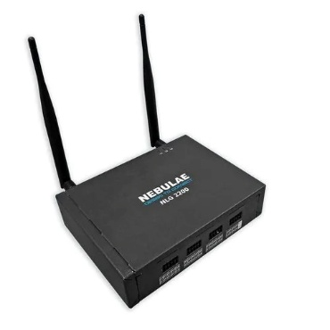
- A Firewall is a security-focused network device that monitors and filters incoming and outgoing traffic based on an organization's previously established security policies. It acts as a protective barrier between a trusted internal network and an untrusted external network (like the public internet) to block malicious data and unauthorized access.
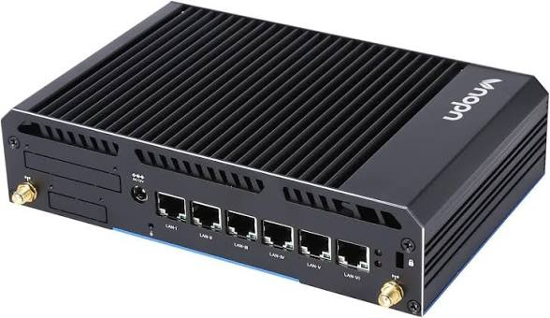
- A Bridge is a device used to divide a large, congested network into smaller, more manageable segments or to connect two separate local area networks (LANs) that use the same protocol. It inspects incoming traffic and uses MAC addresses to decide whether to pass the data frame across the bridge, preventing unnecessary traffic from flooding the entire network.
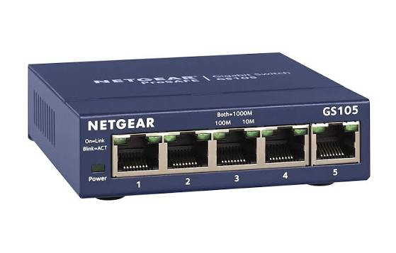
- A Brouter is a hybrid device that combines the functional capabilities of both a bridge and a router. It works intelligently by routing data packets across networks using IP addresses for protocols it recognizes, while automatically falling back to act as a simple bridge to filter and forward data frames using MAC addresses for unrecognized protocols.
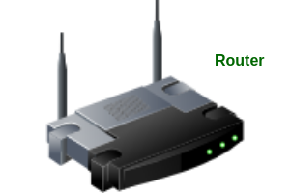
- A Modem is a hardware device that converts digital data from a computer into an analog signal that can travel over physical telephone, cable, or fiber-optic lines, and vice versa. It serves as the physical link that brings an internet connection from your Internet Service Provider into your building, where a router then takes over to distribute it.


